Frampton Cotterell Church of England Primary School
Special Educational Needs and Disabilities Information Report

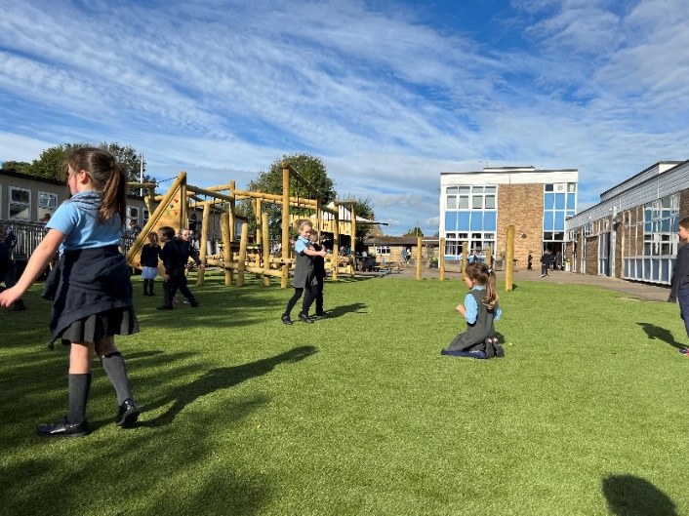
At Frampton Cotterell CE Primary School, every teacher is a teacher of every child, including those with Special Educational Needs and/or Disabilities (SEND.) We are committed to providing an inclusive, ambitious and challenging curriculum that meets the needs of all pupils. In line with the SEND Code of Practice (2015), we recognise our duty to ensure that every child has access to a high-quality, accessible and balanced curriculum. For pupils with SEND, reasonable adjustments and appropriate adaptations are made to teaching and learning to remove barriers to learning and promote full participation. These adaptations aim to enable pupils with SEND to access learning alongside their peers, make progress from their individual starting points and achieve the best possible outcomes.
We believe it is important for all children to develop skills, knowledge and confidence to enable them to become responsible members of their community. We encourage the acquisition of skills that can be applied to future learning experiences which develop children’s social, physical and spiritual wellbeing. We strive to ensure our school environment is a place of safety, is stimulating and enjoyable, a place where memories are made and where all children feel valued and included as part of our school community.
We are committed to promoting equality of opportunity and endeavour to support all our children to be aspirational and to have high expectations. We want them to aim for: ‘Becoming the best we can.’

Our School | At Frampton Cotterell Primary we pride ourselves on treating every child as an individual. We promote inclusivity for all, responding to children’s diverse needs.    We currently have 296 pupils on roll.  There are 60 (20%) children on our SEND register with a range of additional needs.  We have 15 children (5%) with an Education and Health Care Plan (EHCP) and 45 (15%) children have a SEND Support Plan.
Meet our SENDCO and SEND Team | 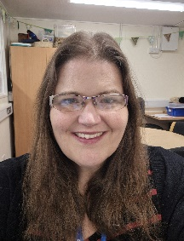  Our Special Educational Needs and Disabilities Coordinator (SENDCO), Mrs Siobhan Barter, coordinates and oversees the leadership of special needs provision across the school and would be happy to discuss any concerns you have regarding your child’s education. Mrs Barter can be contacted via the school office with any concerns: Office@fcceprimary.co.uk  At Frampton we have a strong team of teachers and teaching assistants who work together to support our pupils.  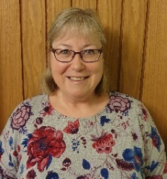  We have an Emotional Literacy Support Assistant (ELSA) practitioner, Mrs Kirstie Ward, who works closely with our SENDCO to coordinate support for our children experiencing emotional challenges.    Mrs Deborah Hodge is our school’s Autism Champion  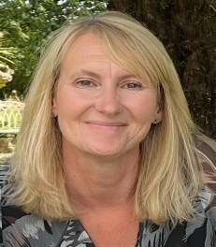  In addition, Mrs Susan Battson is our Family Link Worker, who is able to work with families to improve outcomes for children and offer support with attendance, behaviour and home circumstances. She also supports the Annual Review process for pupils with an EHCP.
Special Educational Needs and Disabilities. | In line with the SEND Code of Practice, we identify pupils as having SEND if they do not make progress once they have received appropriate interventions, reasonable adjustments and Quality First Teaching.  “…A pupil has SEN where their learning difficulty or disability calls for special educational provision, namely provision different from the additional to that normally available to pupils of the same age…”  (Code of Practice 2015 Chapter 6:6.15)  The identification and provision for SEND is categorised into the following broad areas of SEND.  - Communication and Interaction, for example speech and language difficulties, Neurodiversity.  - Cognition and Learning, for example, dyslexia, moderate learning difficulties, executive functioning difficulties.  - Social, Emotional and Mental Health, for example, anxiety, response to trauma.  - Sensory and/or Physical Needs, for example, hearing impairments, visual impairments, diabetes, sensory processing difficulties.
Identifying and Assessing Need | Identification  Class teachers formally assess pupils’ progress in reading, writing and maths three times a year. This data is shared with the Senior Leadership Team (SLT) and used as a theme for our ‘Pupil Progress Meetings’. If a child is making less than expected progress, then additional help may be deemed the best possible way to support them.  Teachers will also be assessing children throughout the year to ensure they are making a good rate of progress. This will include non-academic areas of development, such as social and emotional wellbeing or communication needs.  Pupils will be discussed with the SENDCO and if children need continued support which is ‘different or additional to’ their peers, they will be placed on our SEND register. These discussions can also lead to children being removed from the register where assessments show attainment and progress is at age related expectation. These discussions will be shared with families.  What should I do if I am concerned about my child’s progress?  If you have concerns about your child’s progress or their needs, you should initially speak to your child’s class teacher as they are responsible for your child’s progress. Teachers provide high quality teaching, which might be adapted to meet the individual needs of pupils in the class. Please see ‘SEND – The Frampton Way’ document to see the different types of adaptations we can offer. All staff have high aspirations and expectations for all children. If your child is not making expected progress, barriers to learning are identified or they have additional needs to that of their peers, teachers may organise and implement a booster or intervention group.  How do you communicate/consult with parents/carers?  Class teachers will hold initial discussions with parents highlighting the observations made and concerns regarding progress, attainment and development. The voice and views of the child will also be gathered where appropriate and possible. These conversations aim to ensure that:  - A good understanding of strengths and difficulties are developed  - Parent’s concerns are shared  - Agreed outcomes for the child are identified  - Next steps are shared and agreed.  If appropriate, the SENDCO can also be involved in these initial discussions.  If assessments show that with additional intervention, progress is made, no further action is taken. However, if continued support is needed pupils will be added to our SEND register.
Our approach to teaching children with SEND | Where pupils are identified as having SEND, we follow the graduated approach and the four-part cycle of Assess, Plan, Do Review (APDR). The class teacher will draw on their assessments, discussions with parents/carers, and conversations with the children to gain a clear analysis of need. If relevant, advice from external agencies and services will be included. From this analysis of assessment, the class teacher will plan the adaptation of learning or provision of support and implement this either within the classroom or as part of an intervention group, which might be led by one of our skilled Teaching Assistants.  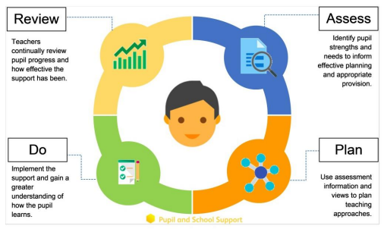  Support Plans will include the following:  - Long term outcomes for the child  - The short-term targets  - Strategies to be implemented to meet the short-term targets  - What the provision will look like  - Exit data  - Review and reflection  Support Plans are reviewed three times a year, in partnership with parents/carers, teachers and pupils in an age-appropriate way. Where possible, we endeavour for the third review to include your child’s next teacher.  Enhanced Provision  We currently have an Enhanced Provision – The Nest. This provision was established to meet the needs of our current cohort. Pupils accessing The Nest have a bespoke curriculum where provision is planned to meet outcomes on EHCPs. During the day, some of our pupils will attend interventions led by The Nest staff, but the majority of their day will be in their own classroom.
Education and Health Care Plans (EHCP) | An EHCP is a legally binding document that is issued by the Local Authority (LA). If your child requires an EHCP, it means they have been identified as needing a higher level of individual or small group teaching which is ‘additional to and to different from’ their peers and above the financial budget available to schools.  An application will often involve contributions from outside services, including Educational Psychology, Speech and Language Therapy or Occupational Therapy.  The SENDCO will be able to discuss the EHCP process with you and how support is implemented if a plan is issued by the LA.
Parent/Carer Consultations | At Frampton Cotterell Primary, we work closely with parents and recognise their important contributions to support pupils with SEND.  During the school year, parents/carers are invited to attend two parents’ evenings, one in the Autumn term and one in the Spring term. To make these appointments, you will be invited to use our online booking system.  Teachers also write a formal end of year report for all children in the Summer term.  If your child is identified as having SEND and has a Support Plan, you will be invited to book a meeting (using the same system as for parents’ evening appointments) with your child’s class teacher to review progress and update targets. These appointments are scheduled for the start of Term 2, 4 and 6.  During Support Plan reviews, class teachers will provide ideas and examples of how you can support your child’s development or with specific areas of need at home. Our SENDCO, Family Link worker or external professionals may offer further advice for your family or signpost you to agencies offering specific support. During these reviews we will ask for your views and opinions on your child’s learning which will be documented on their Support Plan.  For pupils with an EHCP, they will have an Annual Review meeting in addition to the forementioned meetings above. The purpose of the Annual Review is to respond to and review the outcomes of the EHCP. This also provides a formal opportunity to celebrate your child’s progress and learning and discuss next steps.  Parents/Carers will be provided with copies and/or emailed Support Plans and EHCP documentation.
Child Consultations | At Frampton Cotterell Primary, we believe that pupil voice is important and valid. Our pupils are involved in decisions about their education and are made aware of the support available to them.  Children who have a Support Plan contribute to the process by sharing their views and opinions about their strengths and challenges as well as identifying strategies and support they find helpful.  Children with an EHCP, contribute their views as part of the Annual Review meeting where their thoughts will be shared.
Educational trips and residential camps. | Your child’s Special Educational Need or Disability will be taken into account when planning school trips/camps. We consistently aim for inclusion and for all our pupils to have access to the same opportunities and experiences.  Staff will work closely with staff from the venue or setting to modify activities to include all children to best match their needs. Staff will visit all new camp/trip locations to assess accessibility should there be any physically disabled children in the cohort. Appropriate numbers of staff will accompany children depending on their age and any Special Educational Need or Disability within the class. Should a child have an identified need, parents may be contacted to accompany their child on the trip if appropriate.  Medications/asthma inhalers can be administered by staff whilst children are away on camps for longer than one day. Staff will also carry first aid kits and will have parental contact details for all children on the trip/camp. All children are included in all parts of the school curriculum, and we aim for all children to be included in school trips. We will provide the necessary support to ensure that this is successful.  A risk assessment is carried out prior to any off-site activity to ensure everyone’s health and safety is not compromised. On the rare occasion that it is considered unsafe for a child to take part in an activity, then alternative activities which will cover the same curriculum areas will be provided in school.
Accessibility | Frampton Cotterell Primary is accessed via flat paving and kerbs are dropped where appropriate. Gates to enter the playground in the mornings are accessible and there are no steps to enter the building either from the main entrance of the side gates.  The main school building is one storey. We have two classrooms on the first floor accessed by a flight of stairs. Where pupils are unable to access stairs, the classes are changed for the year. This is possible as we have three classes per year group phase, so pupils will always be taught in their cohort group. We have a stand alone building that houses 4 classrooms, toilets and 2 working areas. This is accessed by steps and also has a ramp to allow access to all rooms in the building. Included in this building is an accessible toilet and another is located in the main school building.  Our school has three outside spaces, 2 large playgrounds and an astro-turf areas with play equipment. There is also an enclosed playing field. These areas are accessible for wheelchair users.  Equipment to support children is often purchased directly by the school. In the case of a large piece of equipment e.g. a hoist, needed for a particular length of time, we would look to hire or loan it.  Should a pupil have a visual or hearing impairment, the Local Authority may provide visual aids such as magnifiers, books with enlarged print, personal iPads, visualisers etc. The school may have to identify appropriate resources to allow for the physical adaptation of the environment, for example the use of acoustic panels. This allocation will come from the school’s delegated budget.
Transition Support | At Frampton Cotterell Primary, we recognise that starting school, moving from one year group to the next, from one Key Stage to the next and then on to secondary school can be particularly challenging and often unsettling. We aim to carefully plan transitions and take steps to ensure these are as smooth as possible by:  - Meeting with Early Years settings, liaising with staff, including the SENDCO.  - Visiting children in their Early Years settings to observe strategies in place and begin to develop an awareness of strengths and challenges.  - Providing opportunities for your child to visit school, meet their teacher and become familiar with the environment.  - Using photos and social stories.  - Creating transition booklets that are then sent home over the summer break, which include photos of key areas in school as well as staff members your child will see regularly.  - Meeting with secondary school staff  - Arranging for secondary school staff to come into Frampton to meet the pupils  - Where possible new teachers are involved in the third review of support plans.
Staff Training | Our school is committed to providing and supporting the training of the whole staff CPD and/or individual to address and provide for the needs of our pupils.  Every teacher is a teacher of SEND. Teachers and teaching assistants have regular training through planned INSET days and staff meetings. At times, these are led or supported by external or specialist colleagues. In addition, staff may attend courses run by external professionals. We also have access to training provided by our Cluster or through our Hub.  The SENDCO attends regular network meetings with the Local Authority where new initiatives are shared along with the availability of services in the local area.  Some of the areas our staff have completed training are:  - Inclusion and adaptive teaching  - De-escalation strategies  - Positive Handling  - Phonics  - Bucket time  - PIVATS  - ELSA  - Neurodiversity  - Speech and Language  - Dyslexia Friendly Classrooms  - Zones of Regulation  - Belonging Toolkit
Outside  Agencies | We access external specialist support from outside agencies for pupils as required. These include:  - Speech and Language Therapists  - Occupational Therapists  - Educational Psychologists  - Behaviour Support  - School Nursing Team  - Inclusion Support  - Community Paediatric Services  - Primary Mental Health Services (PMHS)  - Social Care  - Special Needs and Neurodiversity Advisors  Some of these services are arranged through the school, others are accessed via your child’s GP. The SENDCO can offer advice about accessing these services. If we feel it necessary to seek the support of an outside agency, we will ask your permission before arranging this, which might include the signing of paperwork. Once we have received support, we will arrange to share any advice and recommendations with you.
Who can I contact for support? | The first point of contact if you have any concerns about your child is always their class teacher.  Following this, there are other members of staff who may become involved in supporting your child, including the SENDCO, Headteacher, Deputy Head and Family Link Worker.    Headteacher: Mrs Debbie Fisher  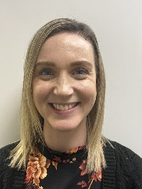  Deputy Head: Mrs Nicola Farrant
South Gloucestershire Local Offer |   The South Gloucestershire Local Authority Local Offer can be found at:  https://find-information-for-adults-children-families.southglos.gov.uk/kb5/southglos/directory/advice.page?id=NkongJNLbul  Parents/Carers may also like to contact SEND and You. More information can be found here:    https://www.sendandyou.org.uk/  We provide an information, advice and support phone line and email service. We’ll listen to your queries and concerns and provide you with information, advice and support on all  kinds of SEND issues at every stage of  child’s education.  You can also contact;    South Glos Parent Carers  South Glos Parent Carers - Supporting Families Since 2009  If you are a Parent Carer in South Gloucestershire with a child aged 0-25 with a Special Educational Need and/or Disability (SEND), we are here for you! We would like to welcome you into our friendly community  and join us in the opportunities we offer for  families of SEND children to come together,  provide support and share experiences.

