Year 1/2  Cycle A | Term 1 | Term 2 | Term 3 | Term 4 | Term 5 | Term 6
Theme | Sticks and Stones | Winter Wonderland | Time travel | Explorers | Global Gardens | Bees
High quality text | 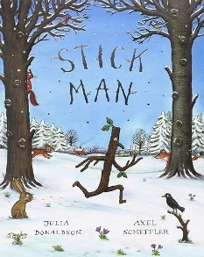 | 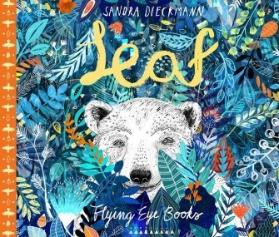 | 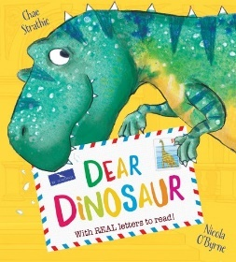 | 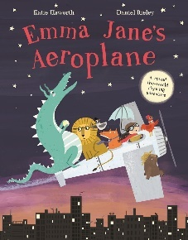 | 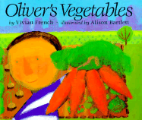 | 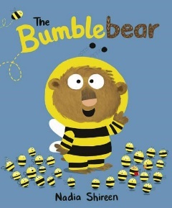
Writing | Narrative: Stickman character description  Recount: Postcard from Stickman | Narrative: Setting description  Instructions | Narrative: Setting description  Recount: Cardiff Museum recount | Narrative: Plot – innovation of Emma Jane  Diary: In role of Emma Jane | Narrative: Innovation of Oliver’s Vegetables  Explanation: Plant lifecycle | Narrative: Consolidation  Non-chron report: Bees
Science | Materials | Animals including humans: Habitats and food chains |  |  | Plants: Lifecycles and where food comes from | Animals including humans: Bee lifecycles
History |  |  | Mary Anning
Geography |  | Polar regions and comparing climates |  | Continents and locational knowledge | Continents and maps
Art | Drawing: Stickman | Painting: Hot and cold colours | Sculpture: Clay ammonites
DT |  |  |  | Make an aeroplane | Flower sculptures | Make a bee
Computing | Computing systems and networks 1  What is a computer?  (3 lessons: 1. 2 and 5 only) |  | Computing systems and networks  Improving mouse skills  (3 lessons: 1-3 only) | Computing systems and networks 2  Word processing | Programming  Introduction to block coding – ScratchJr (4 lessons: 1, 2, 4 and 5 only) | Online safety  Online safety Y1  (all 4 lessons)
Music | Keeping the pulse | Tempo | Pitch | Instruments | Singing | Pitch
RE | Creation | Sikhism | God | Humanism | Gospel | Hinduism
PSHE | Being Me in My World | Celebrating Differences | Dreams and Goals | Healthy Me | Relationships | Changing Me

Year 1/2  Cycle B | Term 1 | Term 2 | Term 3 | Term 4 | Term 5 | Term 6
Theme | Paddington Visits Frampton Cotterell | Christmas Around the World | Once Upon a Time | Great Fire of London | Rainforests | Woodlands
High quality text | 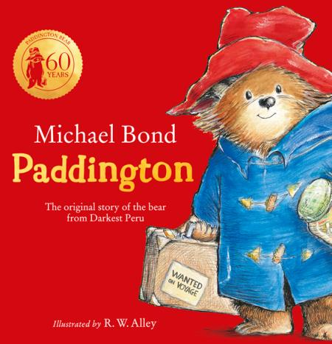 | 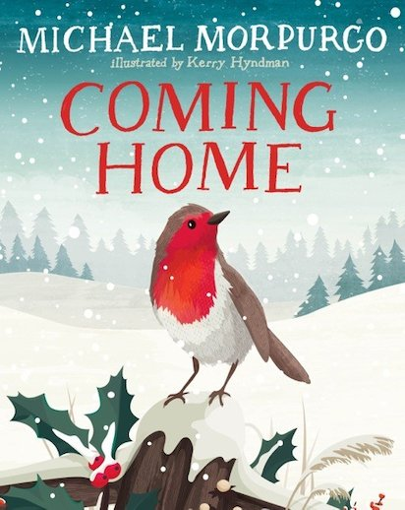 | 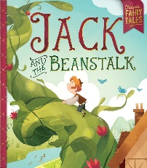  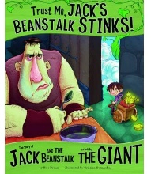 | 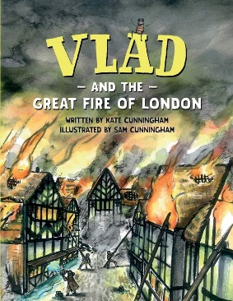 | 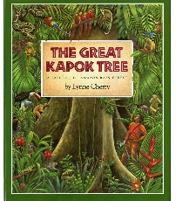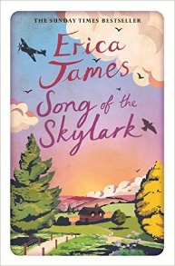 | 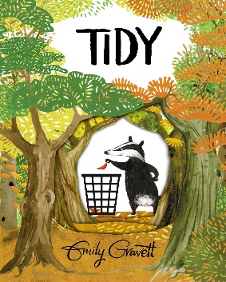
Writing | Narrative: Paddington character description  Recount: Postcard from Paddington | Narrative: Setting description  Discussion: linked to Christmas | Narrative: Plot – innovation and invention of fairytales  Non-chronological report | Narrative: Setting description  Information text: Compare Tudor/modern day houses (report)  Optional fact file about the GFoL | Narrative: Language features  Information text:-different layers of the rainforest (report)  Persuasive letter to the wood cutter to explain why the tree should not be cut down. | Narrative: Consolidation  Recount: school trip
Science |  |  | Animals including humans: Human body and plants |  | Animals including humans | Plants  Seasonal changes
History | Significant historical events, people and places in their own locality: Brunel | Traditions |  | Events beyond living memory: Great Fire of London and Samuel Pepys
Geography | Local area and map skills | Continents and oceans  Compass points |  |  | Place knowledge | Physical geography
Art |  |  | Drawing: Arthur Rackman |  | Painting: Henri Rousseau | Sculpture
DT | Cooking – sandwiches | Cooking |  | Tudor houses
Computing |  | Programming  Algorithms unplugged (4 lessons: 1 2, 4 and 5 only) | Creating media  Digital imagery  (3 lessons: 1-3 only) | Programming  Bee-bot  (4 lessons: 1, 3, 4 and 5 only) | Data handling  International space station  (3 lessons: 1, 3 and 5 only) | Online safety  Online safety Y2  (all 4 lessons)
Music | Dynamics | Sound patterns | Call and response | Musical symbols | Contrasting dynamics | Structure
RE | Islam | Incarnation | World Christianity | Salvation | Judaism | Kingdom of Heaven
PSHE | Being Me in My World | Celebrating Differences | Dreams and Goals | Healthy Me | Relationships | Changing Me

