Year 3/4  Cycle A | Term 1 | Term 2 | Term 3 | Term 4 | Term 5 | Term 6
Theme | Inventors and Achievers | Inventors and Achievers | Romans | Romans | Mayans | Awesome outdoors
High quality text | 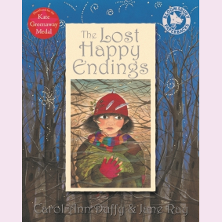 | 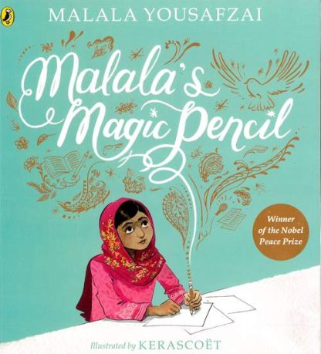 | 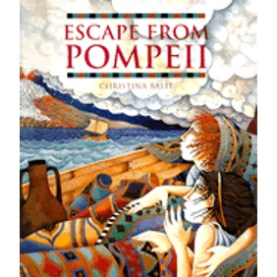 |  | 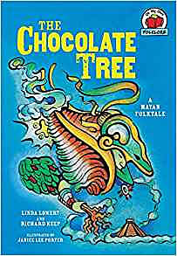 | 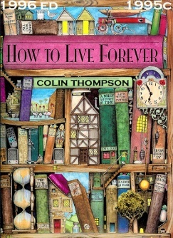
Class novel | 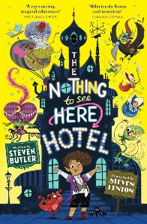 |  | 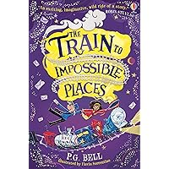 |  |  | 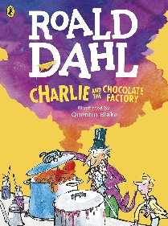
Writing | Narrative: Setting description  Persuasive letter  Biography | Narrative: Characterisation  Newspaper report (recount) | Narrative: Plot  Instructions: How to make a Roman shield  Persuasion | Narrative: Focus on dialogue  Non-chron report  Recount: letter home as a soldier | Narrative: Language features  Discussion  Instructions: how to make chocolate | Narrative: Consolidation  Book review: How to live forever  Discussion
Science | Sound | Electricity | Forces and magnets |  | Living things and their habitats | Plants
History |  |  | The Roman Empire and its impact on Britain | The Roman Empire and its impact on Britain | Mayans
Geography | Comparison | European country comparison: Italy and the UK |  |  |  | Awesome outdoors: fieldwork
Art |  | Painting | Sculpture |  |  | Sketching: plants and flowers
DT | Mechanisms |  |  | Shields | Chichen Itza/masks
Computing | Computing Systems and Networks  Networks (3 lessons: 1, 3 and 5 only) | Programming  Programming: Scratch (4 lessons: 1, 2, 3 and 5) | Programming  Further coding with Scratch (3 lessons: 2-4) | Computer systems and networks  Collaborative learning: Google (4 lessons: 1, 3, 4 and 5) | Online safety  Online safety: Yr 3 (teach all lessons, combine lessons 4 and 5)
French | This is me |  |  |  | My country | My birthday
Music | Instrumental lessons: South Africa | Developing singing technique: Vikings | Instrumental lessons: Caribbean | Body and turned percussion | Jazz | Adapting and transposing motifs
RE | Creation | Sikhism | The people of God | Humanism | Gospel | Hinduism
PSHE | Being Me in My World | Celebrating Differences | Dreams and Goals | Healthy Me | Relationships | Changing Me

Year 3/4  Cycle B | Term 1 | Term 2 | Term 3 | Term 4 | Term 5 | Term 6
Theme | All Around Frampton | My Healthy Body | The Egyptians | The Egyptians | Prehistoric Britain | The Wonderful World of Science
High quality text | 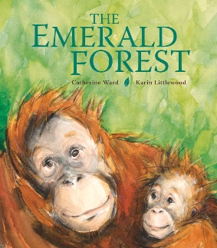 | 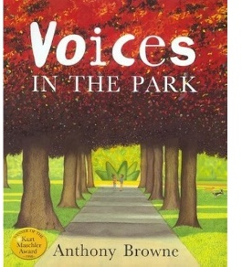 | 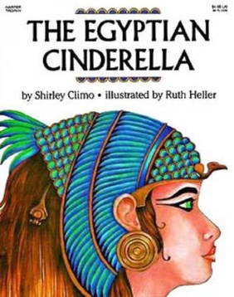 | 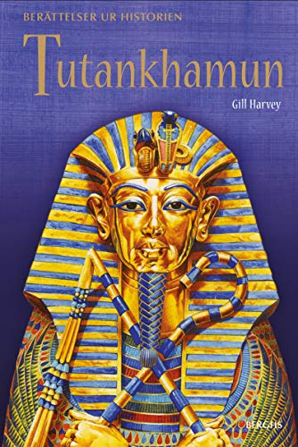 | 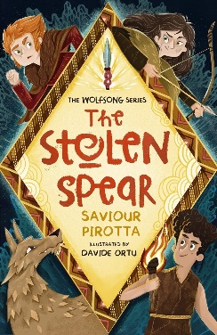 | 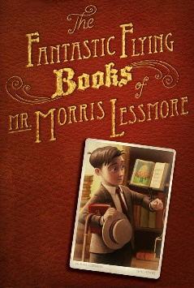
Class novel | 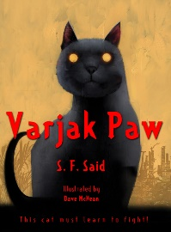 |  | 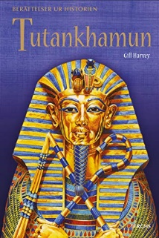 | 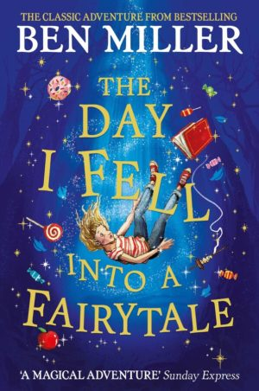 | 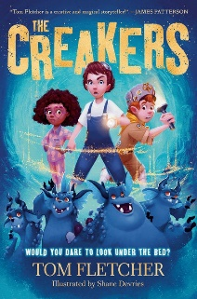 | 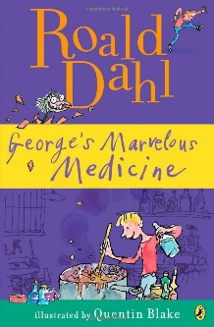
Writing | Narrative: setting description  Instructions: how to escape the Emerald forest  Discussion: You should not cut down the forest | Narrative: characterisation  Non-chron report: healthy living  Instructions: healthy meal | Narrative: plot  Persuasion: come to Egypt  Recount: Egyptian Cinderella | Narrative: plot  Recount diary entry: in role as Howard Carter  Non-chron report: Egyptian Gods and Goddesses | Narrative: power of 3  Information: Bronze Age, Iron Age, Stone Age  Persuasion: come to my island | Narrative: consolidation  Explanation: linked to Science  Newspaper report
Science | States of matter | Animals including humans | Animals including humans |  | Rocks | Light and dark
History |  |  | The achievements of the earliest civilisations:  Ancient Egypt | The achievements of the earliest civilisations:  Ancient Egypt | Changes in Britain from Stone Age to Iron Age
Geography | Frampton and Me |  | River Nile (2x lessons) |  |  | A Wonderful World – fieldwork
Art |  |  | Sculpture |  | Cave painting | Drawing
DT | Hats - sewing | Cooking – fruit kebab, smoothie, pizza |  | Egyptian boats
Computing |  | Computing systems and networks  Journey inside a computer (3 lessons: 1, 2 and 5) | Creating Media  Video trailers: using devices other than iPads (4 lessons 1-4) | Data Handling  Investigating weather (3 lessons: 1, 3 and 4) | Programming  Computational thinking (4 lessons, 1-4) | Online safety  Online safety Yr 4 (4 lessons: 1, 2, 3 and 5)
French | My family | Colours |  |  |  | My body
Music | Creating a composition in response to an animation | Rock and roll | Ballads | Haiku, music and performance | Changes in pitch, tempo and dynamics | Samba and carnival sounds and instruments
RE | Islam | Incarnation | World Christianity | Salvation | Judaism | Kingdom of Heaven
PSHE | Being Me in My World | Celebrating Differences | Dreams and Goals | Healthy Me | Relationships | Changing Me

