Year 5/6  Cycle A | Term 1 | Term 2 | Term 3 | Term 4 | Term 5 | Term 6
Theme | Our climate | Our climate  I’m Alive | I’m Alive  Blitzed Brits | Blitzed Brits | Ancient Greece | Ancient Greece
High quality text | 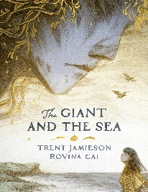 | 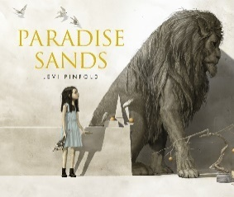 | 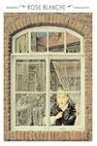 | 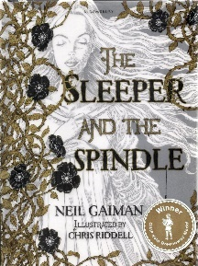 | 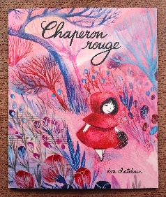 | 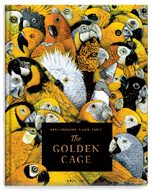
Class novel | 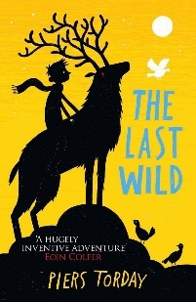 |  | 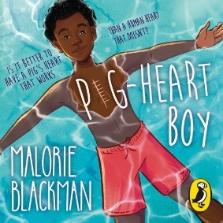 |  | 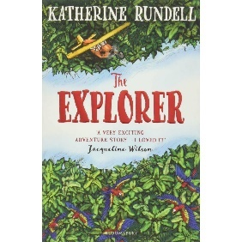
Writing | Narrative: setting  Non-chron report: climate  Persuasion: letter to governors about climate change | Narrative: characterisation  Explanation: circulatory system  Persuasion: charity  Biography: Nelson Mandela | Narrative: dialogue  Explanation: evolution  Non-chron report: WW2 | Narrative: plot  Explanation: hot to survive the Blitz  Recount: letter home from evacuee | Narrative: language features  Discussion: which Greek God is the best?  Recount: diary entry as Greek God/hero | Narrative: consolidation  Explanation: Journey of a river  Recount: Postcard home from river (Y5)  Instructions: Guide to surviving camp (Y6)
Science | Evolution and inheritance | Animals including humans: human body | Living things and their habitat | Light | Animals including humans | Animals including humans: SRE
History |  |  | A local history study: WW2 | A local history study: WW2
Geography | Climate |  |  | Human and physical |  | Rivers
Art | Climate change – pastels |  | Henry Moore - drawing |  | Sculpture – Greek plate/jug
DT | Y5: Bridges  Y6: Bake off | Body maps |  |  |  | Rivers
Computing  Carousel | Data Handling  Mars Rover 1 (3 lessons: 1, 2 and 4) | Programming  Option 1: Programming Music (4 lessons: 2-5) | Data Handling  Big Data 1 (4 lessons: 1, 3, 4 and 5) |  | Programming  Intro to Python (4 lessons: 1-4) | Online Safety  Online Safety Y5 (3 lessons: 1, 4 and 5)
French  Carousel | Animals |  | What’s the time? |  | My school and me
Music  Carousel | Film music | Composition notation: Ancient Egypt | Musical theatre | Theme and variations: pop art | Songs of WW2 | Composing and performing
RE | Creation | Sikhism | The people of God | Humanism | Gospel | Hinduism
PSHE | Being Me in My World | Celebrating Differences | Dreams and Goals | Healthy Me | Relationships | Changing Me

Year 5/6  Cycle B | Term 1 | Term 2 | Term 3 | Term 4 | Term 5 | Term 6
Theme | Bristol and the Slave Trade | Bristol and the Slave Trade/  Earth and Space | Earth and Space | Vikings and Saxons | Ancient Greece | Ancient Greece
High quality text | 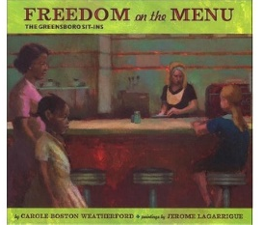 | 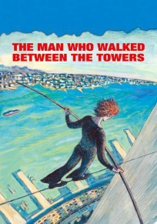 | 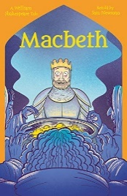 | 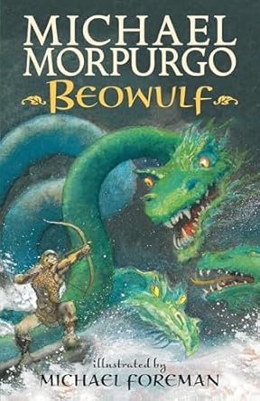 | 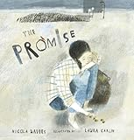 | 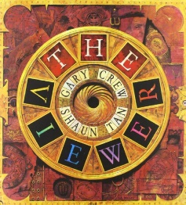
Class novel | 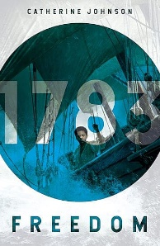 |  | 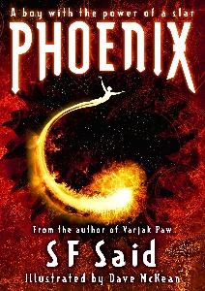 |  | 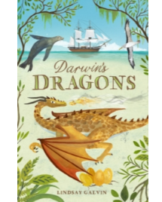
Writing | Narrative: setting  Non-chron report: The Triangular Slave Trade  Biography: Harriet Tubman | Narrative: characterisation  Recount: diary entry as a slave on board ship  Explanation: Christian responses to modern slavery  Persuasion: charity PPTs | Narrative: dialogue  Non-chron report: the solar system  Instructions: how to make a bottle rocket | Narrative: plot  Discussion: were the Vikings good for Britain?  Recount: diary entry as Anglo Saxon | Narrative: language features  Discussion: which Greek God is the best?  Recount: diary entry as Greek God/hero | Narrative: consolidation  Explanation: Journey of a river  Recount: Postcard home from river (Y5)  Instructions: Guide to surviving camp (Y6)
Science | Electricity | Earth and Space | Forces | Materials |  | Animals including humans: SRE
History | A local history study: The Slave Trade | A local history study: The Slave Trade (finish off) |  | Britain’s Settlement by Anglo-Saxons and Scots/The Viking and Anglo-Saxon Struggle for the Kingdom of England to the time of Edward the Confessor | Britain’s Settlement by Anglo-Saxons and Scots/The Viking and Anglo-Saxon Struggle for the Kingdom of England to the time of Edward the Confessor
Geography |  | Physical geography – extreme events | TBC |  |  | Fieldwork and trip to Frome
Art |  | Drawing |  |  | Sculpture – Greek plate/jug | Painting – Pointillism Seurat rivers
DT | Y5: Bridges  Y6: Bake off |  | Bottle rocket | Anglo Saxon/Viking jewellery/bag/money pouch – sewing focus
Computing  Carousel | Computing systems and networks  Search engines (4 lessons: 1-4) | Creating Media  Stop Motion Studio (4 lessons: 1-4) |  | Computing systems and networks  Bletchley Park and the history of computers (3 lessons: 1-3) | Computing systems and networks  Exploring AI (3 lessons: 1, 2 and 5) | Online Safety  Online Safety Y6 (4 lessons: 1, 2 4 and 6)
French  Carousel | What do you want? |  | Sports |  | Clothes
Music  Carousel | Looping and remixing | Blues | Dynamics, pitch and texture | Composition to represent the festival of colour | South and West Africa | Composing and performing
RE | Islam | Incarnation | World Christianity | Salvation | Judaism | Kingdom of Heaven
PSHE | Being Me in My World | Celebrating Differences | Dreams and Goals | Healthy Me | Relationships | Changing Me

